# Name of game: Far from Home

# Story:

The was a big storm in Chitwan, so animals get lost from their home. Animals are very sad and they want to go back to their home. Please help them cross the road according to their sizes in ascending order. Follow the traffic rules too.

# About game

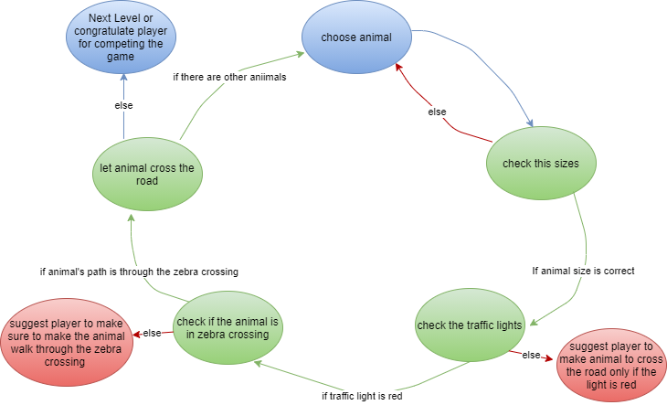

# Initial and final objectives

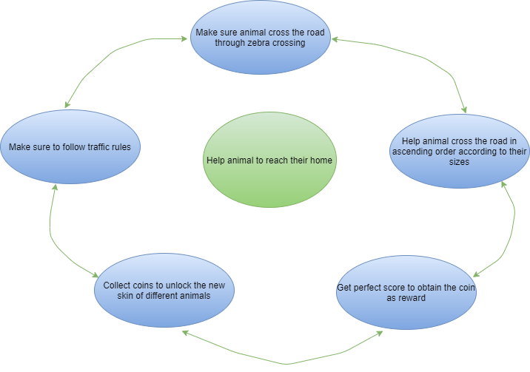

# Interaction

Press the animal’s name and the animal will be selected as a sim character and move the animal but tapping on the path to cross the road. While selecting the animal the voice of the animal is given and the name of the animal is pronounced.

## Grandma

She is a guide like a dialogue bot which will appear at the down-left side of the screen. She will help and give suggestions. Both her voice and dialogue her will be there in the game.

# Game Objects:

Traffic light:

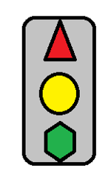

Zebra crossing:



Vehicles:





Animals:

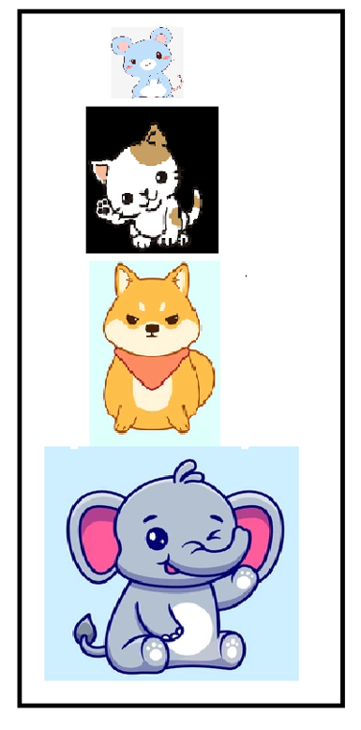

**Game World:**

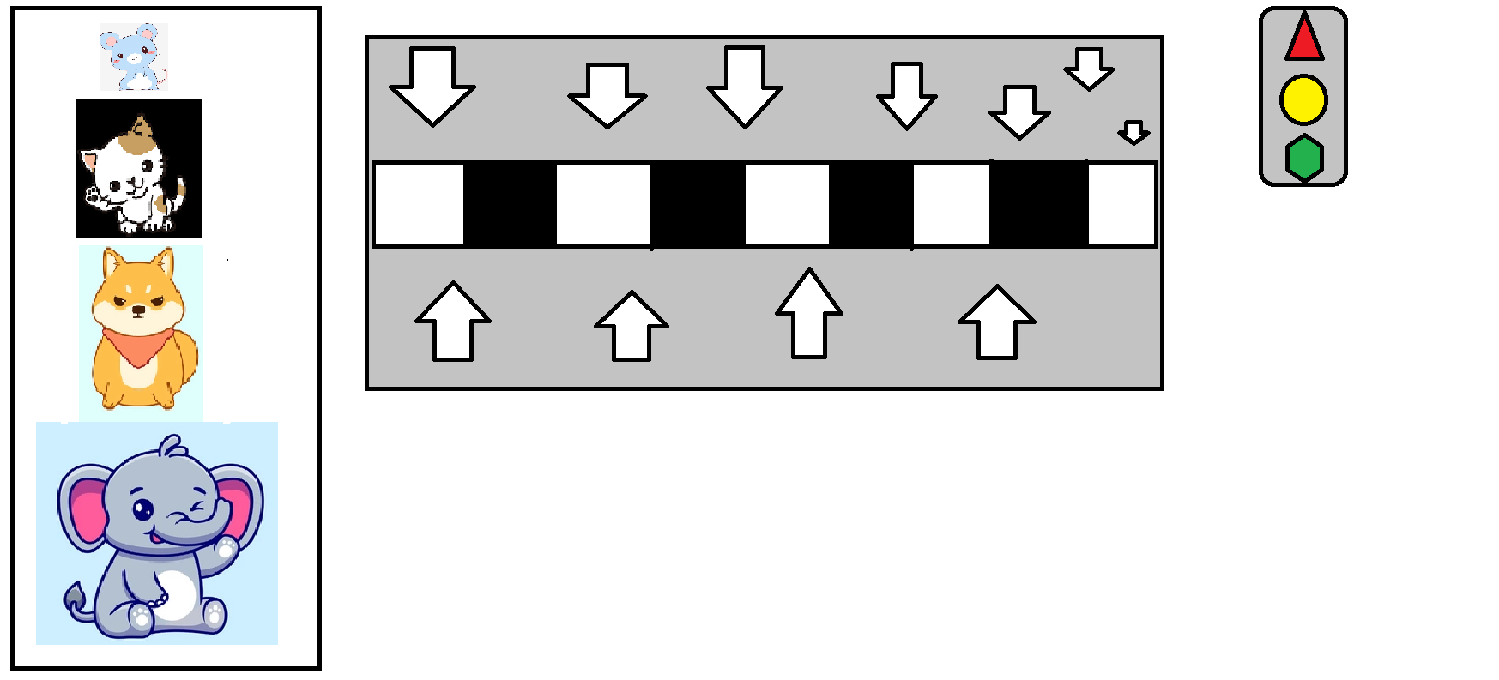

# Game description

We have to simulate the animal to cross the road following the traffic rules. The animal must cross the road according to their size. This game has a grandma character as a guide which will help and suggest the player while helping the animals to cross the road. Players will get a coin for every perfect point which will help players to unlock new skins of animals. When the game ends, all the animals will thank our players for helping them to reach their homes.

How do players know about sizes?

There is an animal chart for that where players will see and learn about the animal sizes.

# Goal

## Main Goal

Help animal to reach their home (jungle)

## Secondary Goal

Help animals to cross the road

# Obstacle

Sizes of animal and traffic rules

# Animals

1. Mouse

2. Cat

3. Dog

4. Rabbit

5. Frog

6. Panda

7. Monkey

8. Deer

9. Kangaroo

10. Elephant